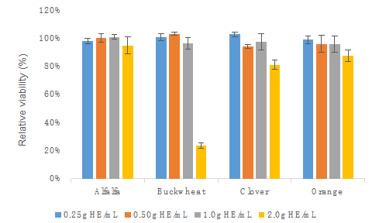

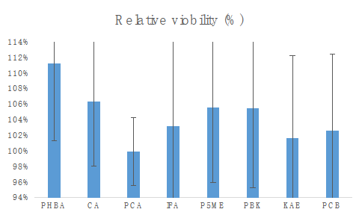

Figure S1. WST-1 viability of Caco-2 BBe1 cell treated with 0.25, 0.5, 1.0 and 2.0 g HE/mL of the phenolic extracts of alfalfa, buckwheat, clover, and orange honeys (A); and major phenolic acids (). Value are expressed as relative viability (%) and presented as mean ± SD, n = 4. *p*-hydroxybenzoic acid (PHBA), caffeic acid (CA), *p*-coumaric acid (PCA), isoferulic acid (IFA), pinobanksin-5-methyl ether (P5ME), pinobanksin (PBK), kaempferol (KAE), pinocembrin (PCB).