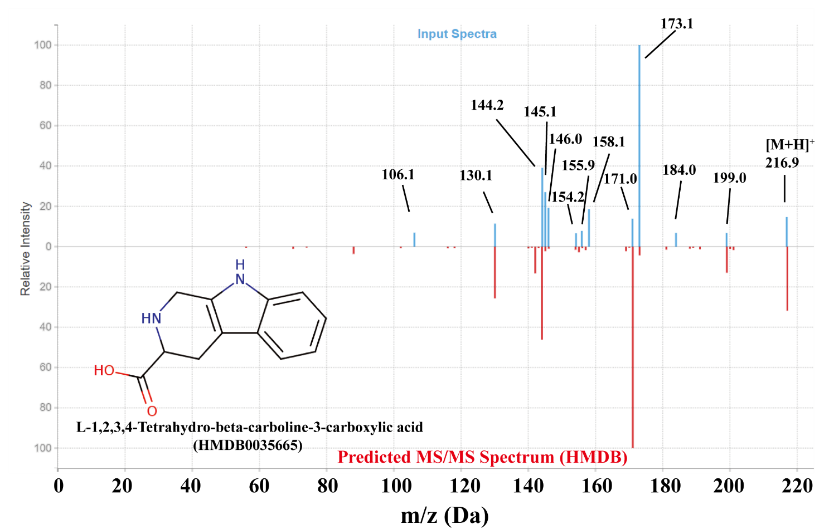

Figure S2. Head-to-tail plot of experimental and predicted LC-MS/MS spectra of L-1,2,3,4-tetrahydro-beta-carboline-3-carboxylic acid. The product ion scan was measured at -15 V, and the matching spectrum predicted by HMDB. The experimental input spectrum is shown on top in blue, and the closest matching result spectrum is shown underneath in red.

