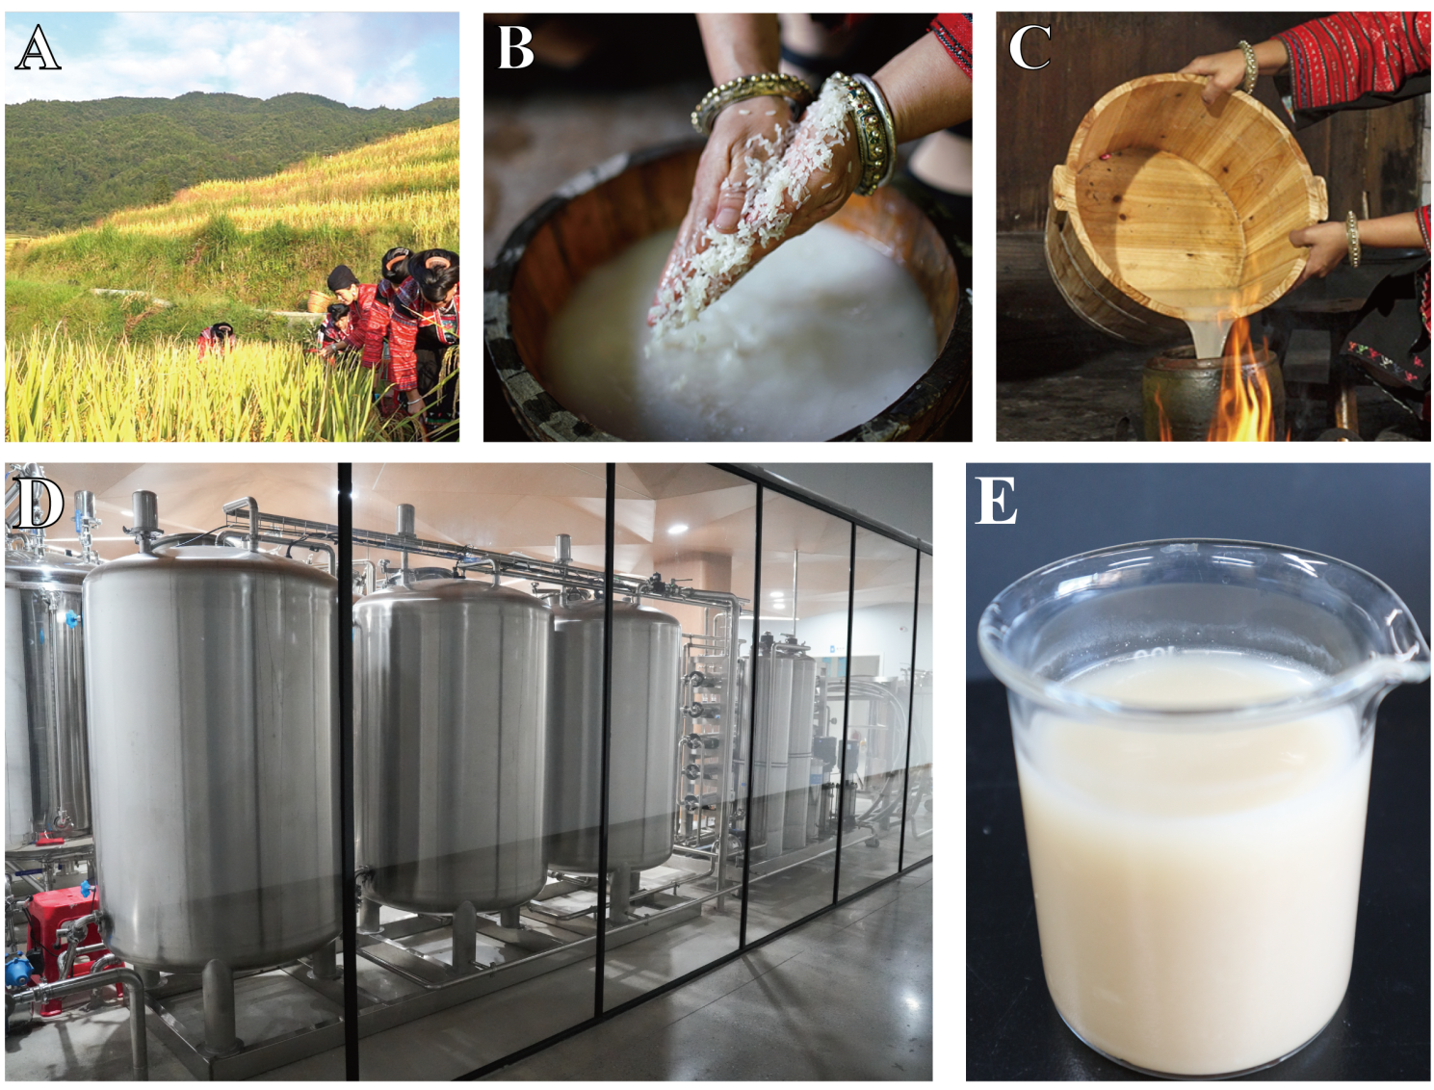
Figure S1. Preparation of Hong Yao sour soup in home and industry scale.
A; Rice is harvested in Huangluo Yao Village. B; Rice is washed in water to get the rice washing water. C; After rice washing water is boiled on a stove in each home, it is fermented at room temperature for at least 7 days without using a starter. Fermentation is facilitated by airborne bacteria. D; Large-scale manufacturing is carried out by Guilin Chang Fa Xiao Zhai Biotechnology Co., Ltd located in Huangluo Yao Village. Local rice and water are used as raw materials. Homemade Hong Yao sour soup collected from several homes is used as the starter. During fermentation process, pH and total acid number (TAN) are monitored for quality control. The values are controlled within pH 2.5-3.0 and TAN＞3.0. E; The appearance of Hong Yao sour soup produced by this company, which was used in this study.

