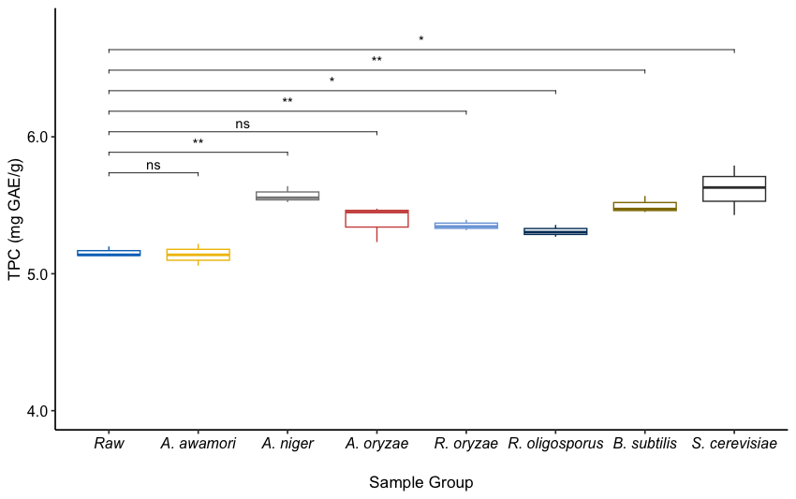
Figure S2. Total phenolic contents (TPC) of yellow mustard bran before (raw) and after autoclaving. “*”, “**”, and “***” indicate significance at p<0.05, 0.01, and 0.001, respectively. “ns” means no significant difference.

