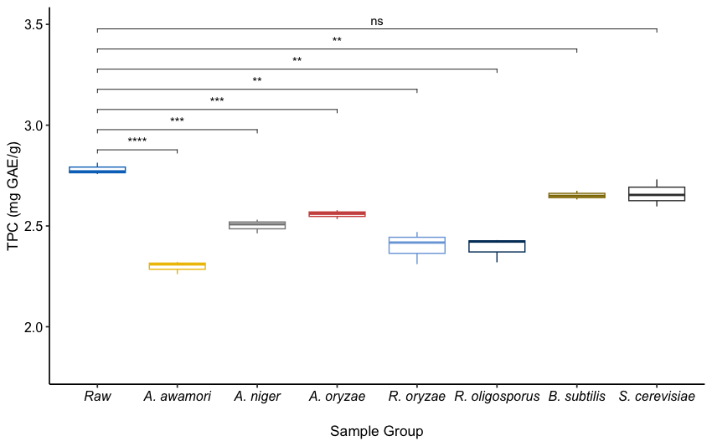
Figure S1. Total phenolic contents (TPC) of oriental mustard bran before (raw) and after autoclaving. “*”, “**”, “***”, and “****” indicate significance at p < 0.05, 0.01, 0.001 and 0.0001 respectively. “ns” means no significant difference.

