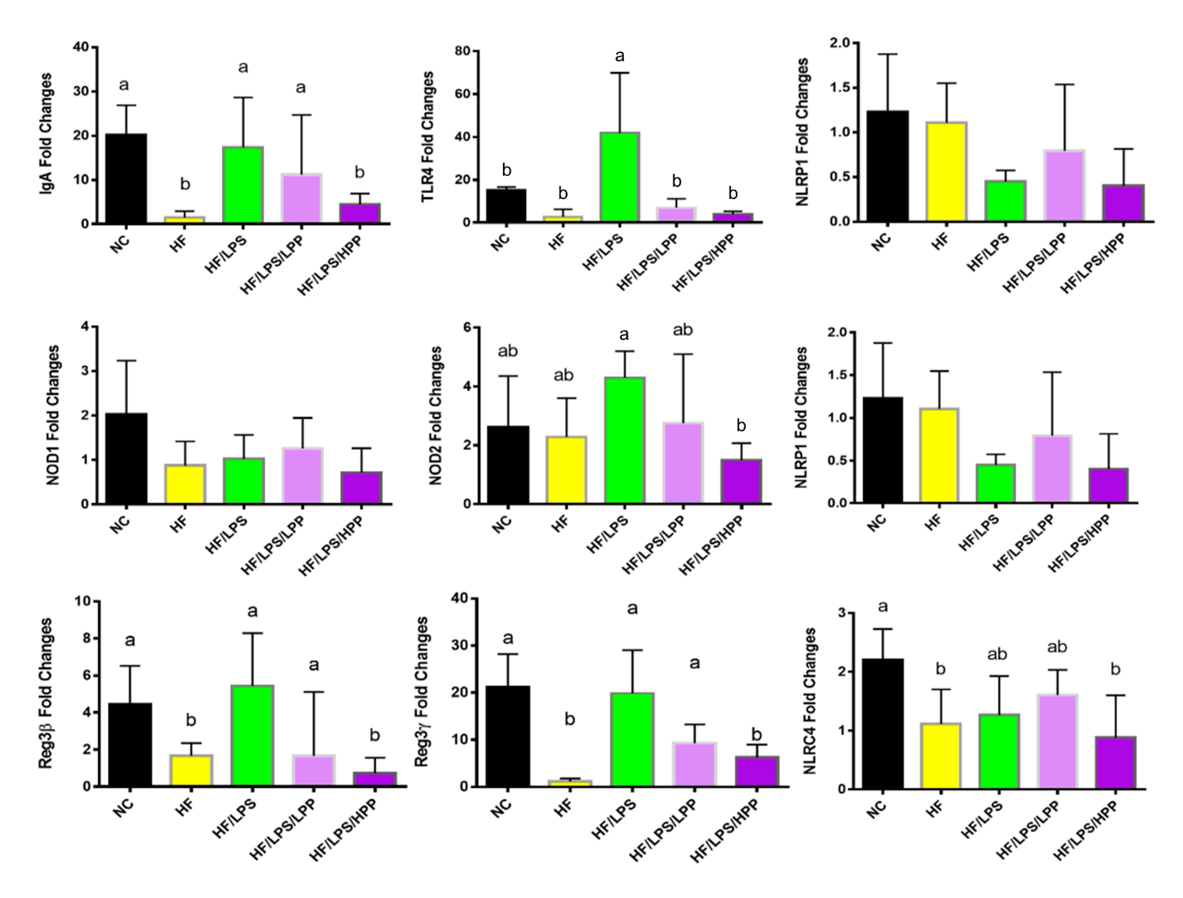
Figure S1. The impact of PPE on the gut sensing activity. The negative control (NC) group represents the mice that have a normal diet, while the HF/LPS and HF represent the mice administered with HFD with or without LPS. The mice pre-treated with PPE at low and high doses are designated LPP and HPP, respectively. Results are represented as mean ± SEM, n = 6. Values without a common letter are significantly different at p < 0.05.

